## Problem D: Tri Tiling

In how many ways can you tile a 3xn rectangle with 2x1 dominoes?

Here is a sample tiling of a 3x12 rectangle.

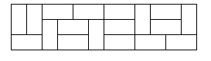

Input consists of several test cases followed by a line containing *-1*. Each test case is a line containing an integer 0 ≤ n ≤ 30. For each test case, output one integer number giving the number of possible tilings.

### Sample input

2

8

12

-1

### Output for Sample Input

3

153

2131

Piotr Rudnicki